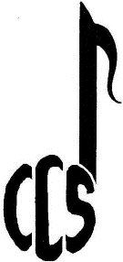
Congleton Choral Society
www.congletonchoralsociety.org.uk
Contact Form
Please complete the following details (please write clearly):
Last Name
Name known by
(First Name)
Address including Postcode
Telephone (mobile and/or landline)
Email
Expected Voice | Soprano / Alto / Tenor / Bass
Privacy Notice: Your details may be shared with other members of the Society as required but no information will be passed to other organisations. For the full details of our Privacy notice, go to https://www.congletonchoralsociety.org.uk/privacy
Many thanks
Phil Edwards
Membership Secretary
membership@congletonchoralsociety.org.uk
07958 692 454

